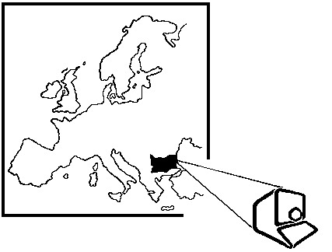 | 2026 IEEE International Conference on Information Technologies  10-11 September 2026, Virtual Forum, TU-Sofia, BULGARIA  REGISTRATION FORM  (separate registration form for each participant)

Please fill in this form and send it no later than July 15th, 2026 to the e-mail addresses:
hinov@tu-sofia.bg & rrom@tu-sofia.bg
PARTICIPANT (* required):
*First Name: |  | *Last Name:
*Title / Degree: |  | *Organization:
*PhD Student (Yes/No): |  | *e-mail address:

REGISTRATION FEE (please, indicate the necessary):
Type of participation | Registration Fee – 20% VAT is included |  | Please, write the amount
Type of participation | Paid before 15 July | Paid AFTER 15 July | Please, write the amount
Participant with 1 report | 250 EUR | 300 EUR
For each additional report | 100 EUR | 120 EUR
Participant without report | 75 EUR | 100 EUR
TOTAL SUM:
Remark: All taxes for the bank transfer must be paid by the participant!

Bank accounts for registration fee PAYMENT:
Payment in EUR
Bank: Eurobank EFG – Bulgaria AD, Sofia, Bulgaria
IBAN: BG 98 BPBI 7940 1446 1397 01
BIC: BPBIBGSF
Beneficiary: “TU-Sofia-Technology” EOOD (InfoTech)

METHOD OF PAYMENT (please, indicate by “YES” the necessary):
● by bank transfer |  | ● in cash
If the payment is made by an organization (not a personal payment), accurate data for issuing a VAT invoice must be presented below:

Date: |  | Name of the participant:

